This software is created using Java technology. In java we can create GUI application using:

1. AWT
2. Swing
3. JavaFX

**Task 1 – Data Import**

We Import the crimedata.sql file into your mysql server database using the HeidiSQL application. This creates a crimedata table and has the following columns:

crime_ID, month, reported by, falls_within, longitude, atitude, location, LSOA_code, LSOA_name,

crime_type. Table have 66,683 records.

**Task 2– Unit Testing**

Not Done.

**Task3 – Database Handling**

We create a class called DatabaseHandler. This class will have a method called handleDbConnection. It has no input parameters and returns a java.sql.Connection object.

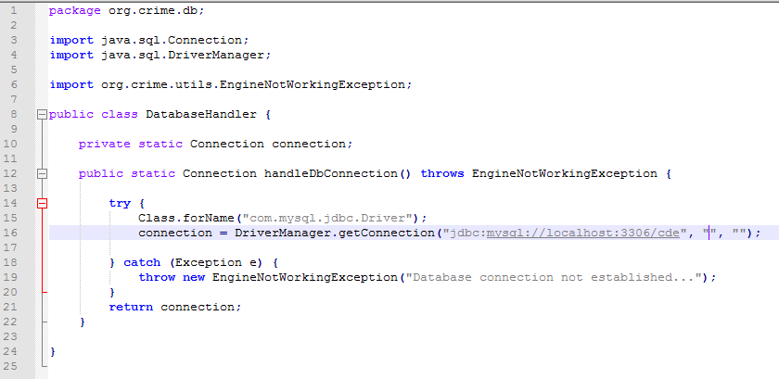

Other methods and classes will call the handleDbConnection () method to use the connection object and query the database.

**Task 4 – GUI building**

There is a class called GUIHandler. This class inherits JFrame with appropriate GUI

components that allow searching for various crime records by:

• longitude and/or latitude and displaying first ten matching results,

• looking up using LSOA name and displaying first ten results

• searching by crime types and displaying first ten results.

**Task 5 – GUI functionality implementation**

This class uses GUIHandler class for displaying GUI. This is JFrame named GUIHandler. This frame has two menu option. (Task No: 3,4 and 5)

1. Export
2. Display

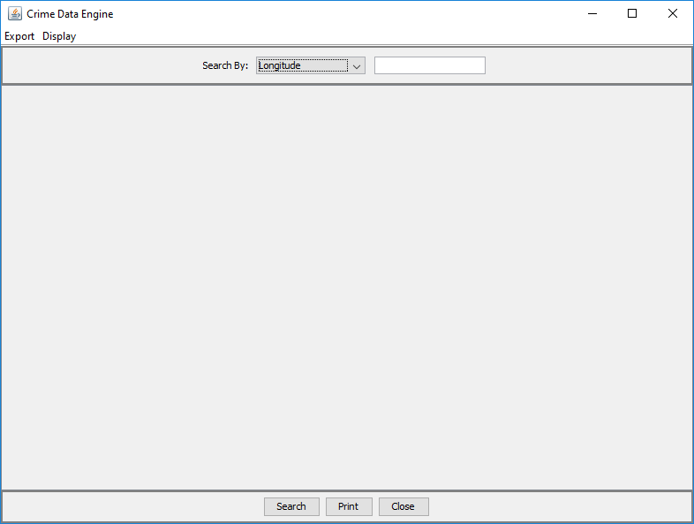

**Export:**

This functionality uses DataQualityCheck.java classes to export data into files. **(Task No: 6)**

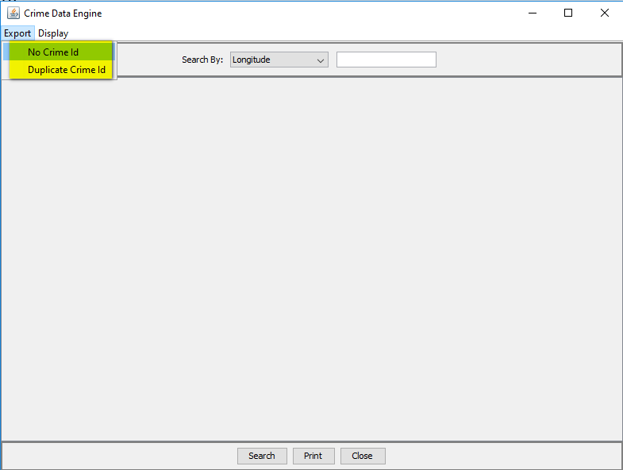

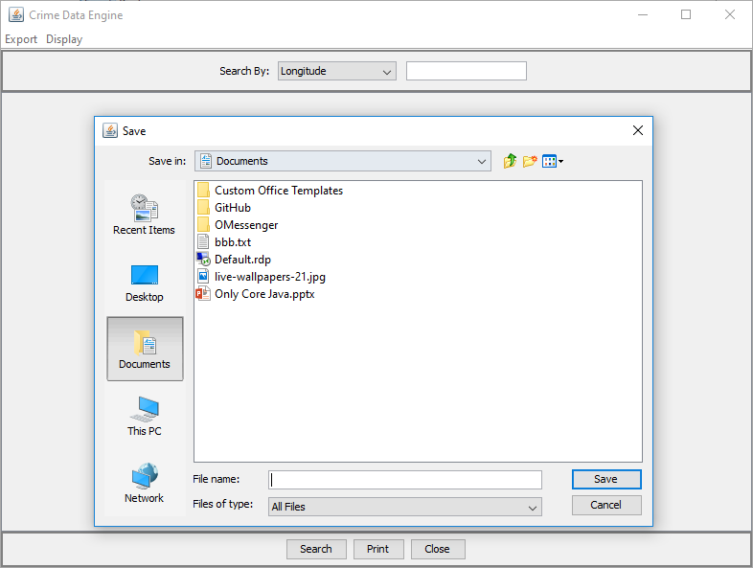

**Task 6– Data Quality Check**

For this task we write a class called DataQualityCheck. This class have appropriate implementation for exporting data:

• Find records within database that have no crime_ID, and export all these records in a file called nocrimeid.txt.

• Find records that have duplicate crime_ID and export these records in a file called duplicatecrimeid.txt.

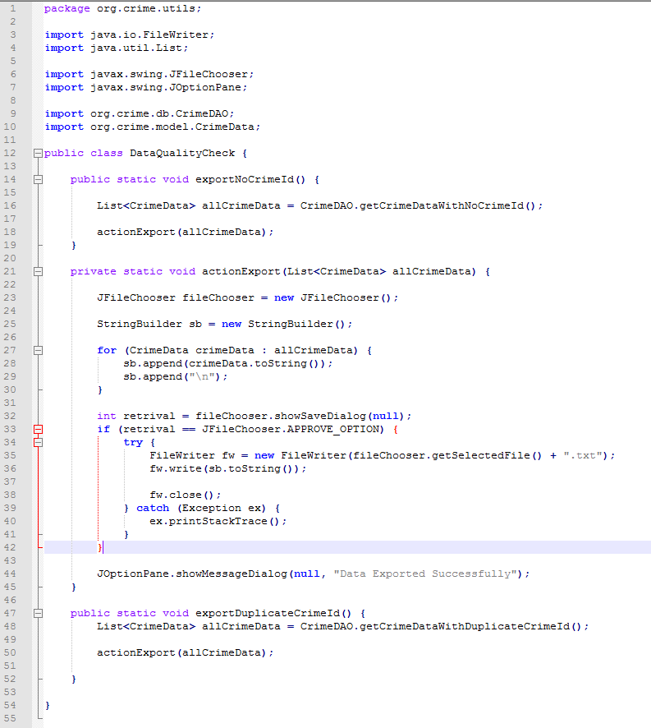

**Task 7 – Errors and Exceptions Handling**

In this application we also use custom exception classes i.e. *CrimeDataNotFoundException.java* and *EngineNotWorkingException.java*.

When program search data from database, if there is a case when no data is found we explicitly throw *CrimeDataNotFoundException,* and when application does not connect with database we throw *EngineNotWorkingException.*

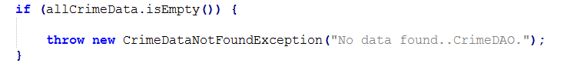

**Task 8– Class Diagram**

We also draw a Class Diagram for describing and documenting all of our implementation using Unified Modelling Language (UML).

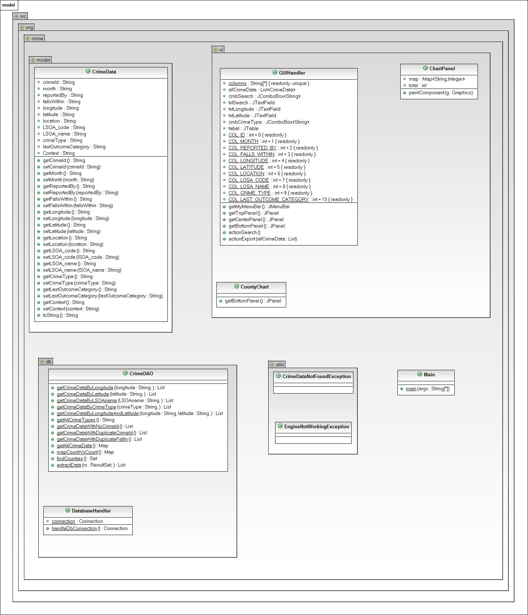

**Task 9 – Additional Features**

We picked *9.1 Visualisation to compare counties*

**9.1 Visualisation to compare counties**

We are draw a bar chart for showing a visual representation in our GUI to compare different counties

(using falls_within field in crimedata table) in terms of total number of crime records in each of them.

We use Java2D for drawing purpose. Responsible classes are:

1. CountyChart.java
2. ChartPanel.java

